Agile Development is type of project structure & management which implements in the tasks of the participants individually/functional teams involved through manner of the “Agile Manifesto and its 12 Principles”.

Michael Gorospe Inso - ACCP Aptech Qatar

Agile Development

Software EA (Expert Advisor) Development using Agile Structure & Methodology



Statement and Confirmation of Own Work

|  |
| --- |
| ***A signed copy of this form must be submitted with every assignment.***  ***If the statement is missing your work may not be marked.*** |

Student Declaration

I confirm the following details:

|  |  |
| --- | --- |
| Candidate Name: | MICHAEL G. INSO |
| Candidate ID Number: | 00188933 |
| Qualification: | L5DC |
| Unit: | AGILE DEVELOPMENT |
| Centre: | APTECH QATAR |
| I have read and understood both NCC Education’s *Academic Misconduct Policy* and the *Referencing and Bibliographies* document. To the best of my knowledge my work has been accurately referenced and all sources cited correctly.  I confirm that this is my own work and that I have not colluded or plagiarised any part of it. | |
| Candidate Signature: |  |
| Date: | 11/1/2020 |

**OPS020_dec16_Candidate+Statement+of+Own+Work.doc**

**OPS020_dec16_Candidate+Statement+of+Own+Work.doc**

Table of Contents

Table of Contents1

Tables and Figures2

Acknowledgement3

Introduction and Theoretical example4

Task 15

1. “Agile Manifesto” Introduction5
2. “Agile Manifesto” Diagram6

Task 27

1. 12 Principles of Agile Development & Methodology and its implementation for the EA (Expert Advisor) Software Development7-9

Task 310

1. Agile Development Stakeholders Advantages 10
2. Hypothetical Selection and Assessment of Head Employees and their Roles11-12

Task 413

1. Implementing Agile Development with Azure DevOps Server Boards13
2. Agile Development Kanban Data Sprints with Azure DevOps Taskboards14
3. Development of EA (Expert Advisor) Software with Azure DevOps 15-17

Task 518

1. Project Plan Questionnaire18
2. Corporate Rights and Responsibilities18

Task 619

1. Agile Development Summary19

References20

Bibliography20

Figures

Figure 1: “Agile Manifesto” diagram6

Figure 2: Implementing Agile Development with Azure DevOps Server Boards 13

Figure 3: Agile Development Kanban Data Sprints with Azure DevOps Taskboards 14

Figure 4: Development of EA (Expert Advisor) Software Economic Calendar data gathering with Azure DevOps15

Figure 5: Development of EA (Expert Advisor) Software MQL5 with Azure DevOps16

Figure 6: Development of EA (Expert Advisor) Software indicators and oscillators with Azure DevOps17

Tables

Table 1: Agile Development Stakeholders Advantages 10

Table 2: Hypothetical Selection and Assessment of Head Employees and their Roles11-12

Table 3: Implementing Agile Development with Azure DevOps Server Boards 13

Table 4: Agile Development Kanban Data Sprints with Azure DevOps TaskBoards 14

Table 5: Project Plan Questionnaire18

Table 6: Corporate Rights and Responsibilities18

**Acknowledgment**

This project would not have been possible with a lot of dedicated special individuals putting their hearts, trust, and faith in me helping me to persevere and be persistent.

I would like to express my special thanks of gratitude to Aptech Qatar Education Centre who gave the amazing opportunity to do this strenuous project on the topic Agile Development for NCC education, which also helped me in doing a lot of exploration and investigation and I acquired so many new knowledge and skills about Agile Structures & Methodology and Project Management & Development.

Secondly, I would also like to thank my family, friends, and relatives who still give me assistance, sponsorship, and accommodation even I’m already a capable adult they helped me a lot in completing this project within a limited duration of time.

**Introduction**

This project will use the theoretical world example of FxThinkBot & Co. Inc. as a registered broker and leading financial services having a total of +200 employees and 10 domestic offices. They are a foreign exchange hedge fund company trading cryptocurrency, stocks, options, futures, indices, commodities, and currency, etc. We will be developing a machine learning & deep learning EA (Expert Advisor) algorithmic trading used by foreign exchange companies and retail traders to have an autonomous execution of orders in the foreign exchange markets and stock markets. In the project management & development of FxThinkBot EA (Expert Advisor), we will be implementing Agile Software Development and Methodology.

**Task 1:**

1. **Agile Manifesto Introduction**

I’ve first heard the term “Agile” from a YouTube video of “Uncle” Bob Martin – “The Future of Programming” from Robert Cecil Martin which he talks about the history of programming and his experiences during the ’70s being a software engineer/programmer and its future will be like in 50-100 years. He is one of the persons with his colleagues in February 2001 who developed the “Agile Manifesto” & “Agile software development”.

Agile Software Development is used all over the world by large, small, private, or public sector companies. The word Agile means is able to “move quickly and easily” in the thesaurus dictionary. Agile Development and Principles isn’t all about being “fast” but more about tackling day to day problems in developing software for the company in sync with “Agile Manifesto and Principles”.

“Agile Manifesto” consists of 4 important values the foundation for Agile Software Development. On the next page, I’ll be showing you an image of large blue boxes and small orange boxes. And I’ll be teaching you the way we peruse the “Agile Manifesto” is from column left to right. It gives more emphasis and importance to the word in the large blue boxes over the small orange boxes it doesn’t mean the word on the small orange boxes are unnecessary or unjustified it only just give more values in the content from the large blue boxes on the right.

**Figure 1:** 

**Individual and interaction over Process and tools**

 **Working software over Comprehensive documentation**

**Customer collaboration over Contract negotiation**



**Responding to change over Following a plan**



(AgileManifesto.org)

* Human Interaction and communication are more important than the use of mechanism.
* Working software is more important than thousands of research substantiation.
* Customer collaboration or partnership is more important than job contract settlements.
* Flexibility is more important than adhering a set of rules or objectives

**Task 2: a.) 12 Principles of Agile Development & Methodology and its implementation for the EA (Expert Advisor) Software Development**

1. **Satisfying the Customer**

* Being able to satisfy the customer with the end result of the project and complementing it with the needs and requirements of the customers.
* In the development of FxThinkBot EA (Expert Advisor), we will be ensuring that has the necessity to perform its trades with the trading strategies the company will be implementing.

1. **Welcoming Change**

* We will be welcoming changes or updates with the current ecosystem which the software will be performing.
* FxThinkBot EA (Expert Advisor) will be able to adjust with current market economic calendar releases, news, trends, and sentiments, etc.

1. **Delivering Frequently**

* Being able to deliver the software in from a couple of days or weeks preferably in the shorter timescale. The sooner we will be able to release the first version the better we will be able to analyze and improve the FxThinkBot EA (Expert Advisor) we are developing.
* The timeframe will be shorter but we will be implementing “Agile Manifesto” working software over thousands of documentations or reports.

1. **Working Together**

* Data scientists, analytics, traders, front-end, and back-end developers, etc. will be working together sharing ideas and solutions having the same goal in mind to build the FxThinkBot EA (Expert Advisor) enabling it to perform in different stages of development.

1. **Build Projects**

* Building FxThinkBot EA (Expert Advisor) is “sine qua non”.
* The project will be surrounded by a motivated individual who will make the software to fruition. Giving them the environment and support they need from the development of the software. The company will be having self-organizing teams and won’t be requiring micromanagement.

1. **Face to Face Time**

* The most powerful and productive way of conveying details is through direct face-to-face discussion within the same environment and scene.
* Each individual will be sharing their important problems and solutions talking directly lessening the use of mobile phone, computer, and email communication, etc. in this way we can be more successful and practical in conveying our details

1. **Measure of Progress**

* Each team will have an agile board and master that will estimate the development of the software FxThinkBot EA (Expert Advisor) being operational software is the premier purpose of each team.
* Substantiation and documentation are not the prerequisite in developing the FxThinkBot EA (Expert Advisor) but a software that can perform the task in buying/selling investment assets for the company and performing fundamental or technical analysis.

1. **Sustainable Development**

* The finance, software, front-end, back-end developers, programmers, and traders should be able to maintain and update support for every new version it will be releasing the FxThinkBot EA (Expert Advisor) with its repositories will be well maintained and developed.
* A long-lasting and enduring FxThinkBot EA (Expert Advisor) is our main objective not a regressing FxThinkBot EA (Expert Advisor) in a proceeding decade.

1. **Continuous Attention**

* The project is well updated to current market trends, sentiments, news, and economic calendar releases, etc. it’s machine learning and deep learning are constantly updated and debugged for errors. Using TensorFlow software we will be able to track the progress of the A.I. more effortlessly and comfortably.
* As it’s machine learning and deep learning grows maturely, we will constantly be watching for inaccuracy and miscalculation to the market.

1. **Keep it Simple**

* The project or software won’t be having too many nugatory attributes. Its UX and UI will be unpretentious and elementary. It won’t be using a lot of indicators and oscillators to have a straightforward process in performing in the market.
* It will still be having simple descriptive CLI, GUI, UX, and UI making it more manageable to the company and retail traders.

1. **Organized Teams**

* The best ideas, scheme, and design comes from self-organizing crews. And able to adapt and function in different fields and specialty developing the software.
* Every data scientist, analyst, software, front-end, back-end developer, and the tester has to be assigned in their respective roles and teams for better productivity and competence.

1. **Reflect for Effectiveness**

* There will be a regular schedule and programme for each team to detail its current progression in the development of FxThinkBot EA (Expert Advisor) sharing their every problem and solutions for better effectiveness.

(12 Principles of Agile Methodology, p. 1)

**Task 3 and Table 1:**

**c.) Agile Development Stakeholders Advantages**

|  |  |
| --- | --- |
| Stakeholders | Advantages |
| Customers / Users | Customers will be able to communicate to a more responsive vendor with every project impediments or variations. Vendors will be able more to adjust to the customers’ needs/wants. Important features and updates are easily available to the customers. |
| Vendors / Merchant / Retailer | Vendors will able to have an accelerated release of the software reducing the schedule to develop the project. It will also decrease inefficiency and wastefulness with the development of the software. Enhancing customer fulfillment being able to confine more attributes. |
| Development Teams | Development teams would be able to appreciate working with a project because of the curtailment of a stressful environment. Resulting in a more productive work environment. Proceeding a primer software. |
| Product Managers / Owner | The product owner will be able to prioritize more predominant characteristics of the software situating to customers’ needs/wants. They will have a more flexible work environment. |
| Project Managers / Scrum Masters | Project managers will find that the planning and execution of a task are more effortless compared to the waterfall methodology. They will be more focus-oriented on software development progress. They will use burndown charts and daily scrum meetings giving them more apprehension about the project. |
| PMOs and C-Level Executives | PMOs and C-Level executives will have more understanding of the progress of the project equating to better strategic planning and implementation of tasks. |
|  |  |

(What is Agile? What is Scrum?)

**Table 2:**

**a.) Hypothetical Selection and Assessment of head employees and their roles**

|  |  |  |  |  |
| --- | --- | --- | --- | --- |
| Name | Skills | Experiences | Employment | Roles |
| Mikigaru Itinawa | Financial trading  Fundamental and Technical Analyst | Worked for Citadel LLC for 10 years of hedge fund trading financial assets from stocks, options, index, futures, commodities, cryptocurrency, and currency, etc. Managing different hedge fund portfolios of clients. | Fulltime or Contract based | Mikigaru Itinawa will be developing fundamentals and technicals and back-testing trading strategies for the FxThinkBot EA (Expert Advisor). |
| Tristania Tecwasno | Financial broker  And Account Manager | Worked for TD Ameritrade for 12 years as a financial broker. Account manager and dealing with clients and executing their bid/ask orders. | Fulltime | Tristania Tecwasno will be a broker and account manager for FxThinkBot EA (Expert Advisor). |
| Motoko Tanaka | Software Developer and Engineer | Highly skilled in programming. Developed several software for Microsoft for 20 years. Head tech lead of software engineering for Microsoft. | Part-time | Motoko Tanaka will be programming and developing FxThinkBot EA (Expert Advisor) database, front-end, and back-end, etc. |
| Bataou Sakamoto | System Engineer | Worked for Cisco for 15 years as a network & system engineer. He manages and ensures all network and communications are available for the company. | Part-time or Contract based | Bataou Sakamoto will manage all network, system, and communication regarding FxThinkBot EA (Expert Advisor). |
| Togusa Aramaki | Software Engineer and Artificial Intelligence Expert | Worked for OpenAI artificial intelligence company for 8 years developing machine learning and deep learning. Highly skilled utilizing TensorFlow. | Fulltime | Togusa Aramaki will be developing machine learning and deep learning with the assistance and utilization of TensorFlow in FxThinkBot EA (Expert Advisor). |
| Akira Aiko | Administrative and Project Manager | Worked as Administrative and Project Manager for 25 years for several banks and brokerage companies Fidelity Investment, Interactive Brokers, and Charles Schwab, etc. | Part-time | Akira Aiko will be the head administrative and project manager for FxThinkBot EA (Expert Advisor). Managing all employees in all departments. |

**Notes:**

FxThinkBot & Co. Inc. is a registered broker and leading financial services having a total of +200 employees and 10 domestic offices.

Employees displayed are the (CFO) Chief Financial Officer, (CTO) Chief Technology Officer, (CMO) Chief Marketing Officer, and (COO) Chief Operation Officer, etc. for the FxThinkBot & Co. Inc.

**Task 4 and Figure 2:**

1. 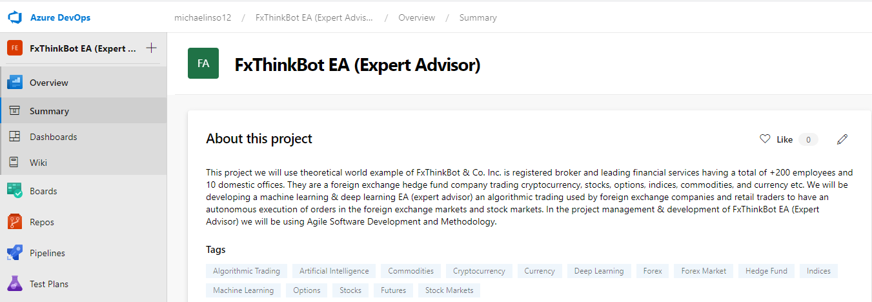**Implementing Agile Development with Azure DevOps Server**

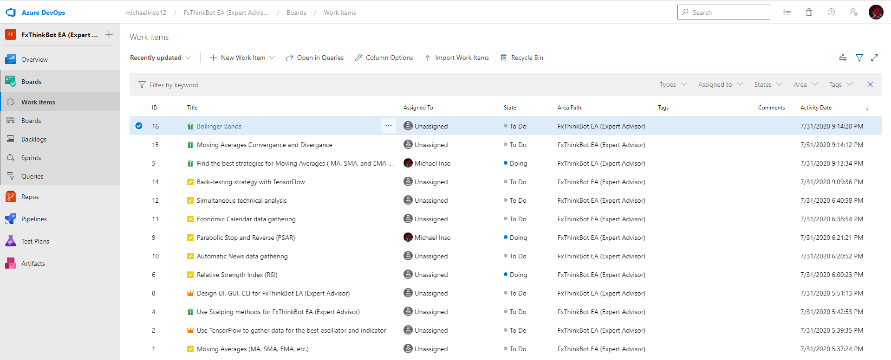**Table 3: Azure DevOps Server Boards (Work Items)**

**Table 3 and Figure 3:**

1. **Agile Development Kanban Data Sprints with Azure DevOps Task boards**

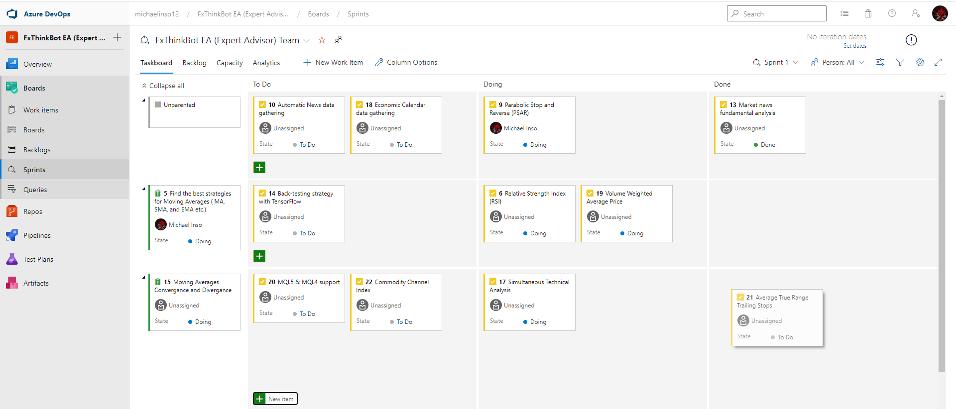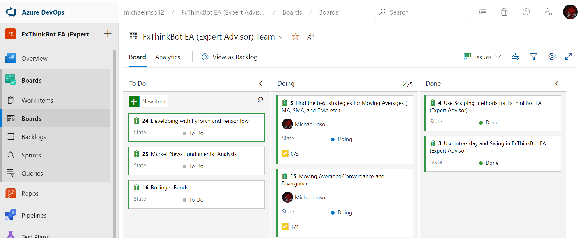

**Figure 4:**

1. 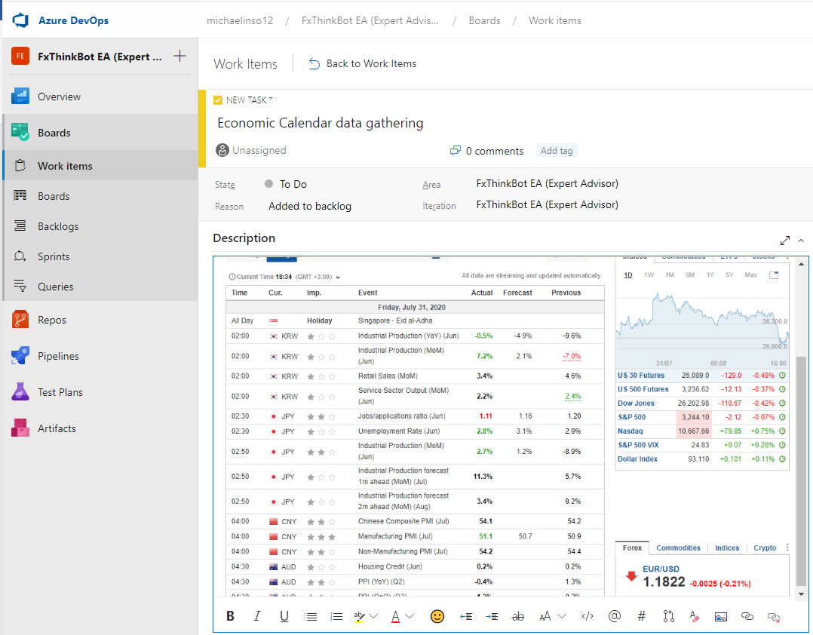**Development of EA (Expert Advisor) Software Economic Calendar data gathering with Azure DevOps**

* In this demonstration FxThinkBot EA (Expert Advisor) will be taking data for fundamental analysis from economic calendar site like www.investing.com/economic-calendar/
* Our software engineers and developers will be coding this website into our FxThinkBot EA (Expert Advisor) and it will respond accordingly depending on the impact of an event and with its actual, forecast, and previous data.

**Figure 5:**

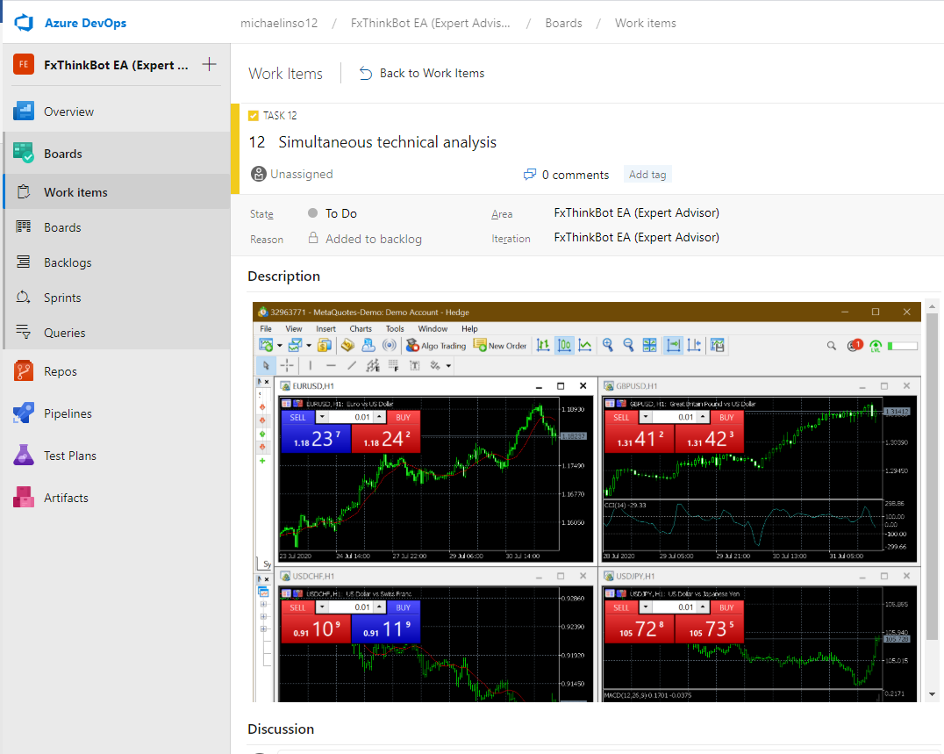**c.) Development of EA (Expert Advisor) Software MQL5 with Azure**

* FxThinkBot EA (Expert Advisor) will be capable to run in MQL5 (MetaQuotes Programming Language 5) the latest terminal client will have the capability to perform simultaneous technical analysis, trading assets from currency, stocks, indices, futures, commodities, options, and cryptocurrency, etc.

**Figure 6:**

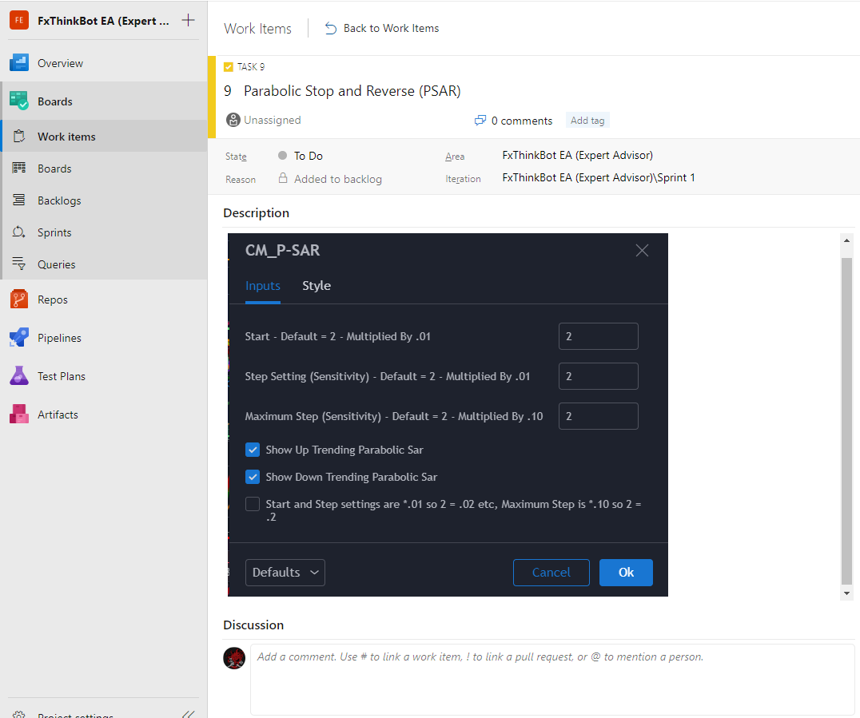**c.) Development of EA (Expert Advisor) Software indicators and oscillators with Azure DevOps**

* FxThinkBot EA (Expert Advisor) will be using a wide variety of indicators and oscillators to perform its technical analysis. One of the indicators is PSAR (Parabolic Stop and Reversal) a lagging indicator that trails price as the trends extend overtime.

**Task 4 and Table 5:**

**d.) Project Plan Questionnaire**

|  |  |  |  |  |  |  |  |
| --- | --- | --- | --- | --- | --- | --- | --- |
| REF | STATEMENTS | STRONGLY AGREE | AGREE | NEUTRAL | DISAGREE | STRONGLY DISAGREE | FEEDBACKS AND ISSUES |
| 1 | Does the team understand the ThinkBot EA (Expert Advisor) software and each role developing it? |  |  |  |  |  |  |
| 2 | All the members are able and willing to cooperate viably with each other? |  |  |  |  |  |  |
| 3 | The members have been oriented to the Agile Software Development Manifesto, Principles, and Practices? |  |  |  |  |  |  |
| 4 | Are all the members able to work-overtime with the limited development timeframe? |  |  |  |  |  |  |
| 5 | Does the team understand all the risks and repercussions in developing this project? |  |  |  |  |  |  |
| 6 | Are all the members able to keep the project confidential in all circumstances? |  |  |  |  |  |  |
| 7 | In case the project got leaked are we able to perform an investigation of all the members? |  |  |  |  |  |  |
| 8 | The team agrees not to do anything illegal privately and publicly while working for the company? |  |  |  |  |  |  |

**e.) Corporate rights and responsibilities**

|  |
| --- |
| FxThinkBot EA (Expert Advisor) final and pre-release version is only available for the use of employees of the company. |
| FxThinkBot EA (Expert Advisor) cannot be distributed publicly without the authorization of the company. |
| FxThinkBot & Co. Inc. has the right to remove you from employment anytime they found you incapable of doing your duties. |
| FxThinkBot & Co. Inc. will not be authorizing illegal insider trading and other illegal trade activities. |
| FxThinkBot & Co. Inc. has the rights to collect its employee’s personal information for its confidential use or research |

**Task 6:**

1. **Agile Development Summary**

* The utilization and implementation of Agile Development, Management, Structures, and Methodology can increase proficiency and alleviate any impediment in software development. Agile Development is a great method for any small, large, public, or private sector company or corporation to exploit. This methodology primarily has been beneficial to the software engineers & developer since it orients mostly to their work ethics and principles.
* Programmers, software developers, and engineers, etc. would have significant utilization of Agile Development and Methodology since they are the ones who are producing and manufacturing software for a company or corporation.
* My history assists me in making this project into a reality since I have a great deal of experience working in a private international logistic company, foreign exchange market brokerage, and trading firm using their capital to trade an asset in the foreign exchange market and stock market for a yield, dividend, net profit, and an ROI (return of investment), etc. That’s why I’m aware of a great number of market terminologies that not a regular citizen would comprehend and understand.
* Making the project was entertaining and gratifying, I was able to procedure a methodology for a realistic functioning software not just subjectively and theoretically within a short period. Many large-cap hedge funds would want to implement this FxThinkBot EA (Expert Advisor) software in their firms. Since a lot of the investing firms or companies nowadays don’t apply many manual executions to analyze and invest in the market. Before the ‘90s before the Dot-com bubble, people need to stand in line, bawl and proceed on a huge trading floor like NASDAQ, NYSE, and S&P 500, etc. for their investment assets to execute in a bid/ask. It’s very distinct today where you can just trade wide diversity of assets with just a monitor and a click of a mouse button.
* People got astute and started developing complex investing/trading algorithms and EA (Expert Advisors) which mostly uses HFT (high-frequency trading) strategies. In the United States alone in 2009, high-frequency trading firms represented 2% of the approximately 20,000 firms operating today but accounted for 73% of all equity orders volume. The major U.S. high-frequency trading firms include Virtu Financial, Tower Research Capital, IMC, Tradebot, and Citadel LLC. -Wikipedia
* Its nuance implementing a Machine Learning and Deep Learning in an algorithm and EA (Expert Advisor) since open-source software libraries TensorFlow and PyTorch, etc. are not available before this last 5 years. It’s when TensorFlow initially released on November 9, 2015, and PyTorch on October 2016, that people started developing machine learning and deep learning implementing it for diverse purposes and uses.

**References:**

**Bibliography**

https://agilemanifesto.org/

https://en.wikipedia.org/wiki/Agile_software_development

https://www.investopedia.com/articles/active-trading/101014/basics-algorithmic-trading-concepts-and-examples.asp

https://www.thebalance.com/what-is-an-expert-advisor-1344951

https://www.cprime.com/resources/what-is-agile-what-is-scrum/

https://www.cgi.com/us/en-us/life-sciences/blog/12-principles-of-agile-methodologies

https://docs.microsoft.com/en-us/azure/devops/boards/work-items/guidance/agile-process-workflow?view=azure-devops

https://docs.microsoft.com/en-us/azure/devops/boards/boards/kanban-basics?view=azure-devops

https://www.opendemocracy.net/en/corporate_responsibilities_4605jsp/

Statistics:

Pages: 21

Words: 3,104

Characters (no spaces): 17,990

Characters (with spaces): 21,226

Paragraphs: 231

Lines: 756